CDG East Branch
Annual General Meeting
Saturday 25 November 2017

2.00 till 3.00 Ringing at St Michael's, Mottram

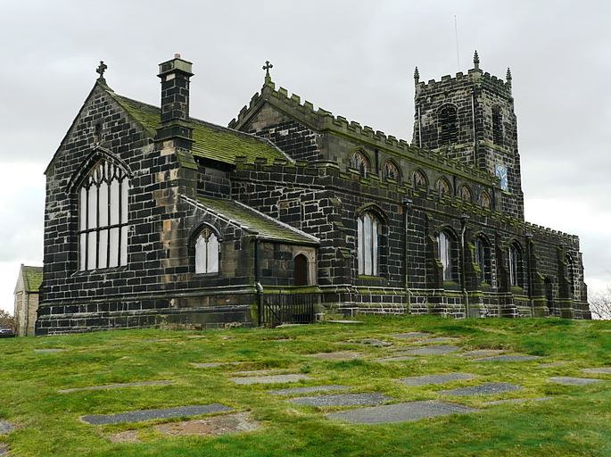

3.30 till 4.30 Ringing at St Paul's, Staley

Service at 4.30, then tea and AGM.
Please send names for tea to Gillian Parkin
by Tuesday 21st Nov.
Contact details: phone 07947 139 124
or email gillianparkin@aol.com
Remember: no name, no nosh!
Clive

